Backyard Science: The Pendulum Power Challenge
Brought to you by Backyard Fun Factory
Turn your backyard swing set into a physics lab! Today, we’re exploring how energy moves and how you can control it with just a ball and your feet.

🧪 The Experiment: Can Gravity Be Fooled?
What You’ll Need:
- A Backyard Fun Factory swing
- A playground ball
- A "Scientist" (You!) and a "Launcher" (A friend or parent)
Part 1: The Energy Mirror
- Sit on the swing and hold the ball in your lap.
- Have your Launcher pull you back until you are high off the ground.
- The Question: If the Launcher stands exactly where you started and holds their hand out, will you hit their hand when you swing back?
- The Test: Let go!
- The Result: You’ll get close, but you won't hit it! This is Conservation of Energy. The swing can never go higher than where it started because gravity only gives you a certain amount of "Potential Energy" at the top.
Part 2: The Foot-Brake Friction
- Get a good rhythm going and swing as high as you can.
- Now, stop "pumping" your legs and gently drag your feet in the woodchips or grass.
- The Science: You’ll feel your shoes get warm! That is Friction. Your feet are turning your "Kinetic Energy" (speed) into heat energy to slow you down.
Part 3: The Heavy Hitter
- Try to swing with just yourself. Then, try to swing while holding a heavy ball or having a sibling join you.
- The Science: Notice how much harder your Launcher has to push to get you started? That’s Inertia. Objects with more "mass" (weight) want to stay still and require more force to move!

Backyard Fun Factory Tip: Always make sure your swing hangers are tightened before starting your experiments!

📊 Diagram Description: The Energy Cycle

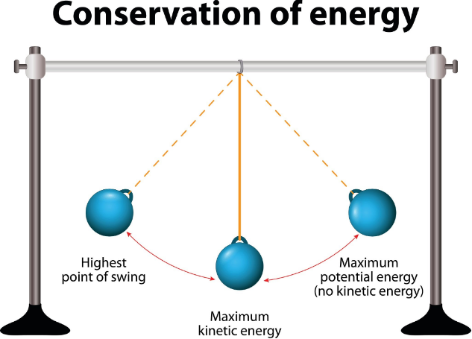
Licensed by Google

- The High Points (Left & Right): Label these as "Potential Energy" (Stored Energy). This is where the swing pauses for a split second before gravity pulls it back down.
- The Low Point (Middle): Label this as "Kinetic Energy" (Motion Energy). This is where the swing is traveling at its fastest speed.
- The Arc: Draw a curved arrow showing the path, labeled "The Pendulum Swing."

🛡️ Scientist Safety Checklist
Before you begin your experiment, check off these 5 safety rules:
- [ ] Clear the Launch Zone: Make sure there are no toys, pets, or other scientists in the path of the swing (front or back).
- [ ] Proper Footwear: Always wear closed-toe shoes (like sneakers). Doing the "Friction Test" with bare feet can cause "ouches"!
- [ ] Sit Securely: Keep your bottom firmly on the seat. This experiment is designed for sitting, not standing.
- [ ] The "No-Jump" Rule: Stay on the swing until it comes to a full stop. Never jump off while the swing is in motion.
- [ ] Hold Tight: Keep at least one hand on the swing chain at all times, even while holding the ball.

