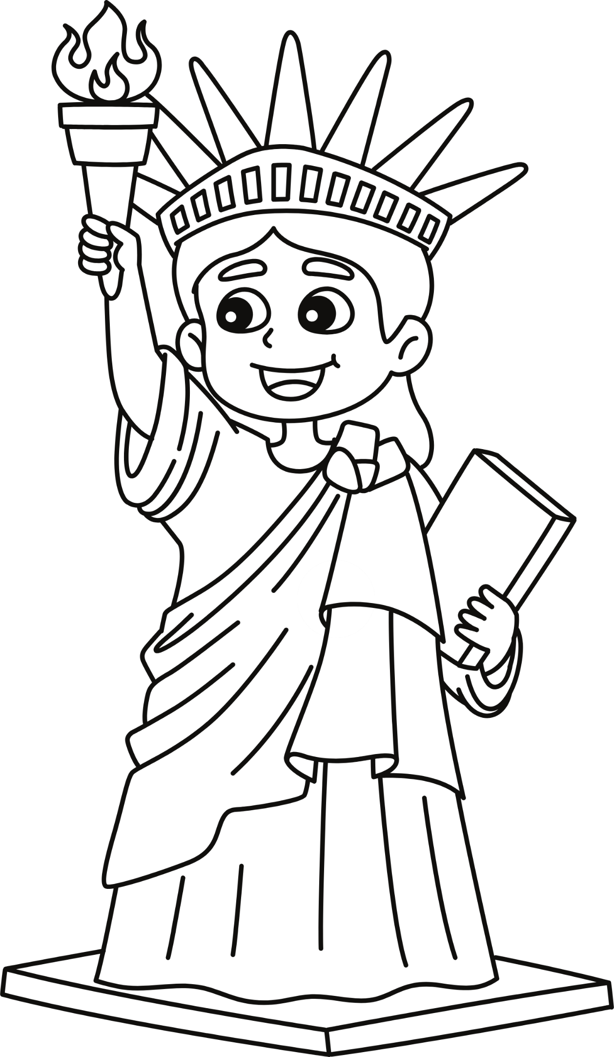

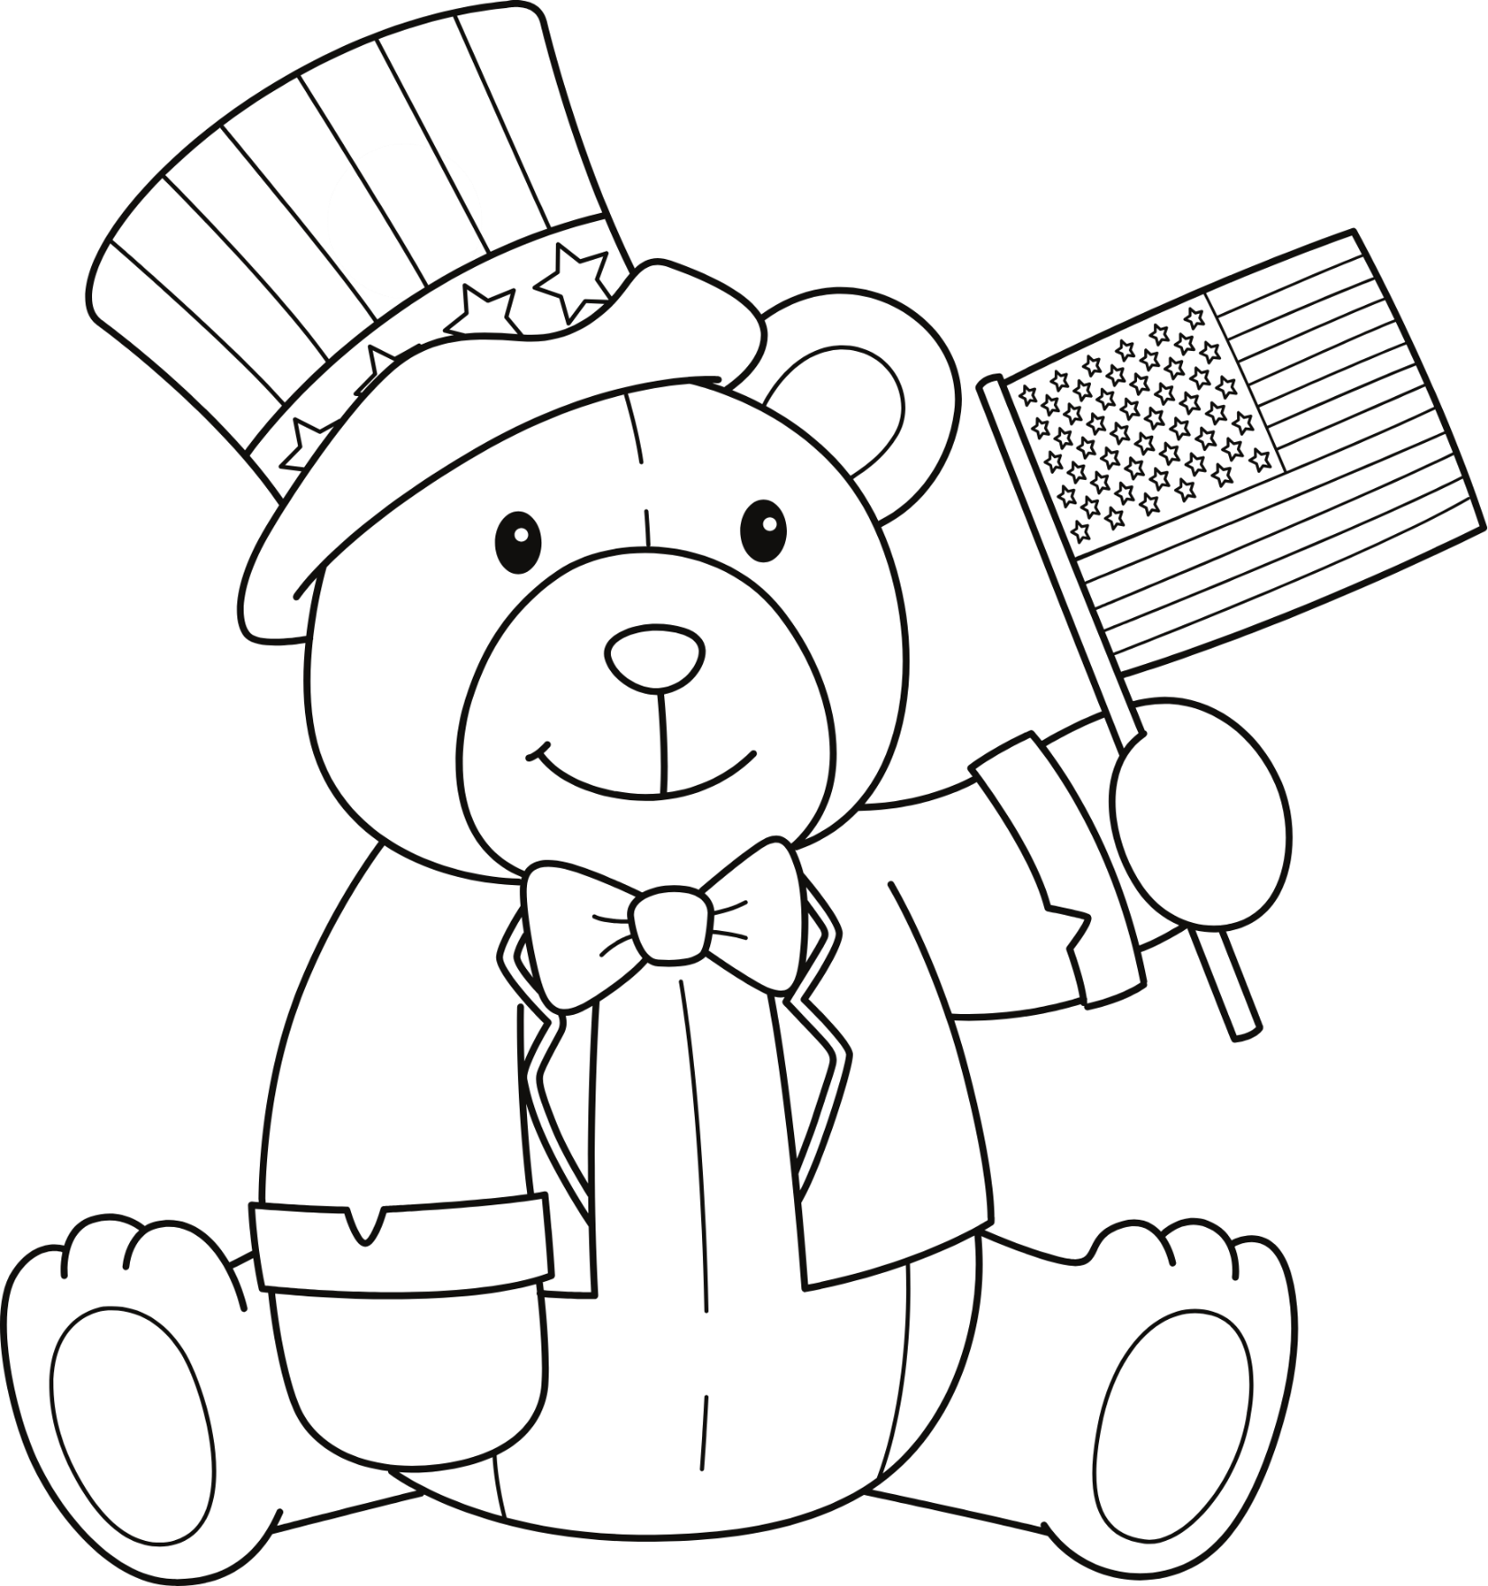

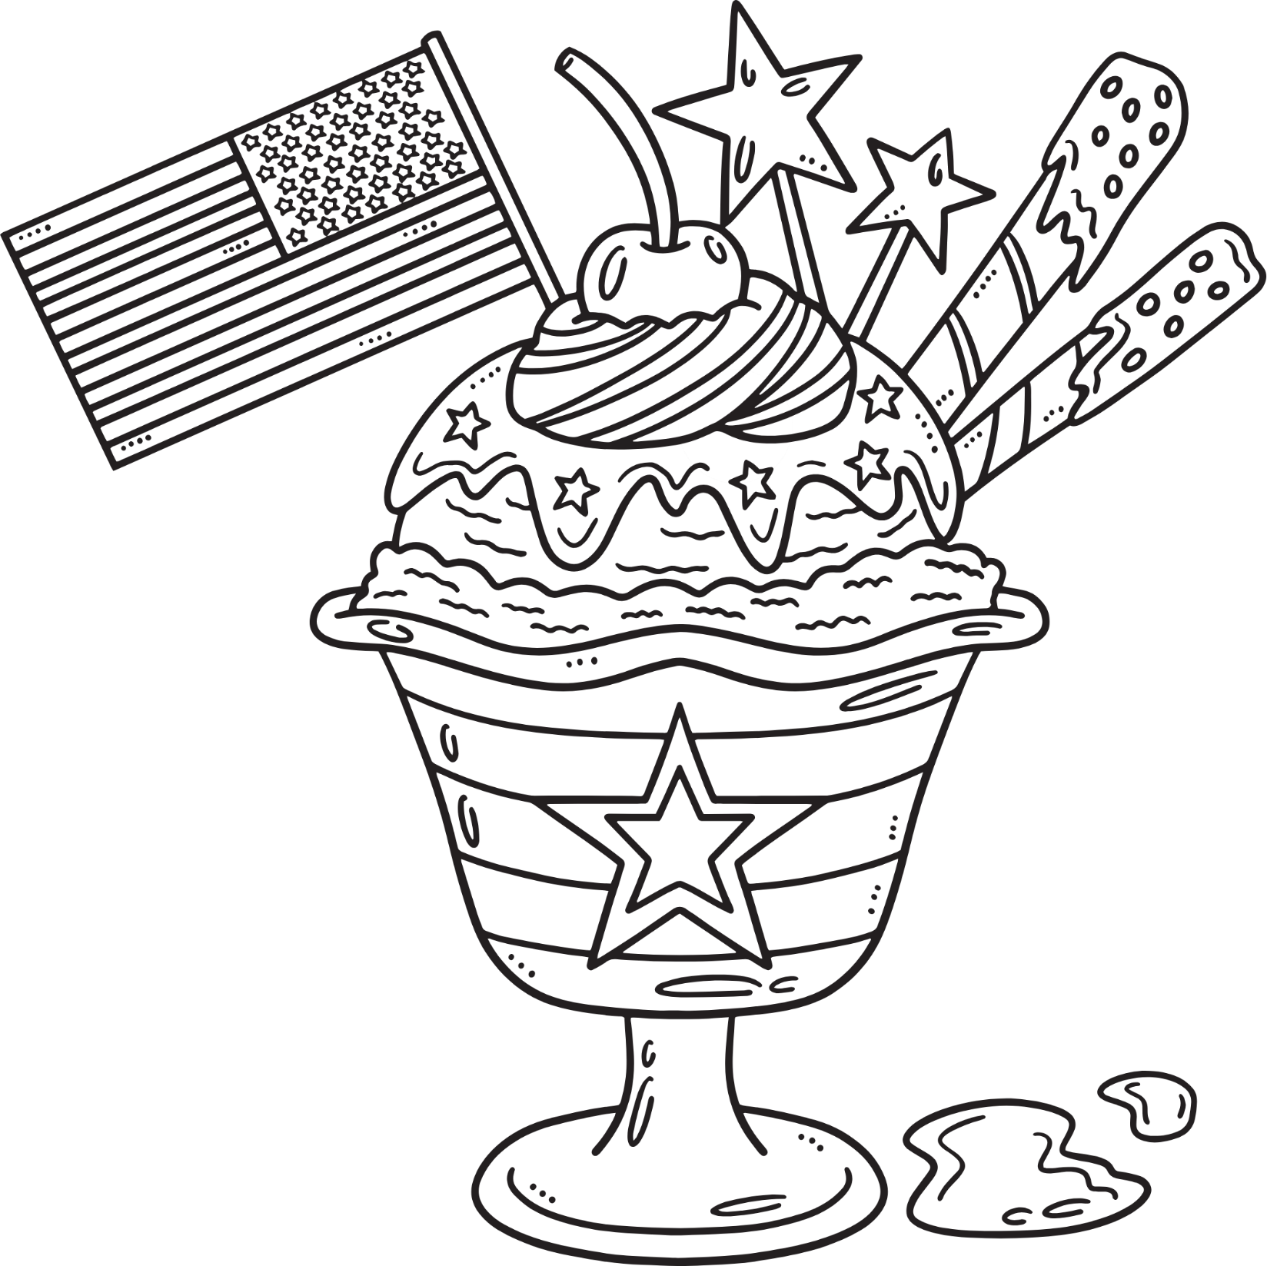

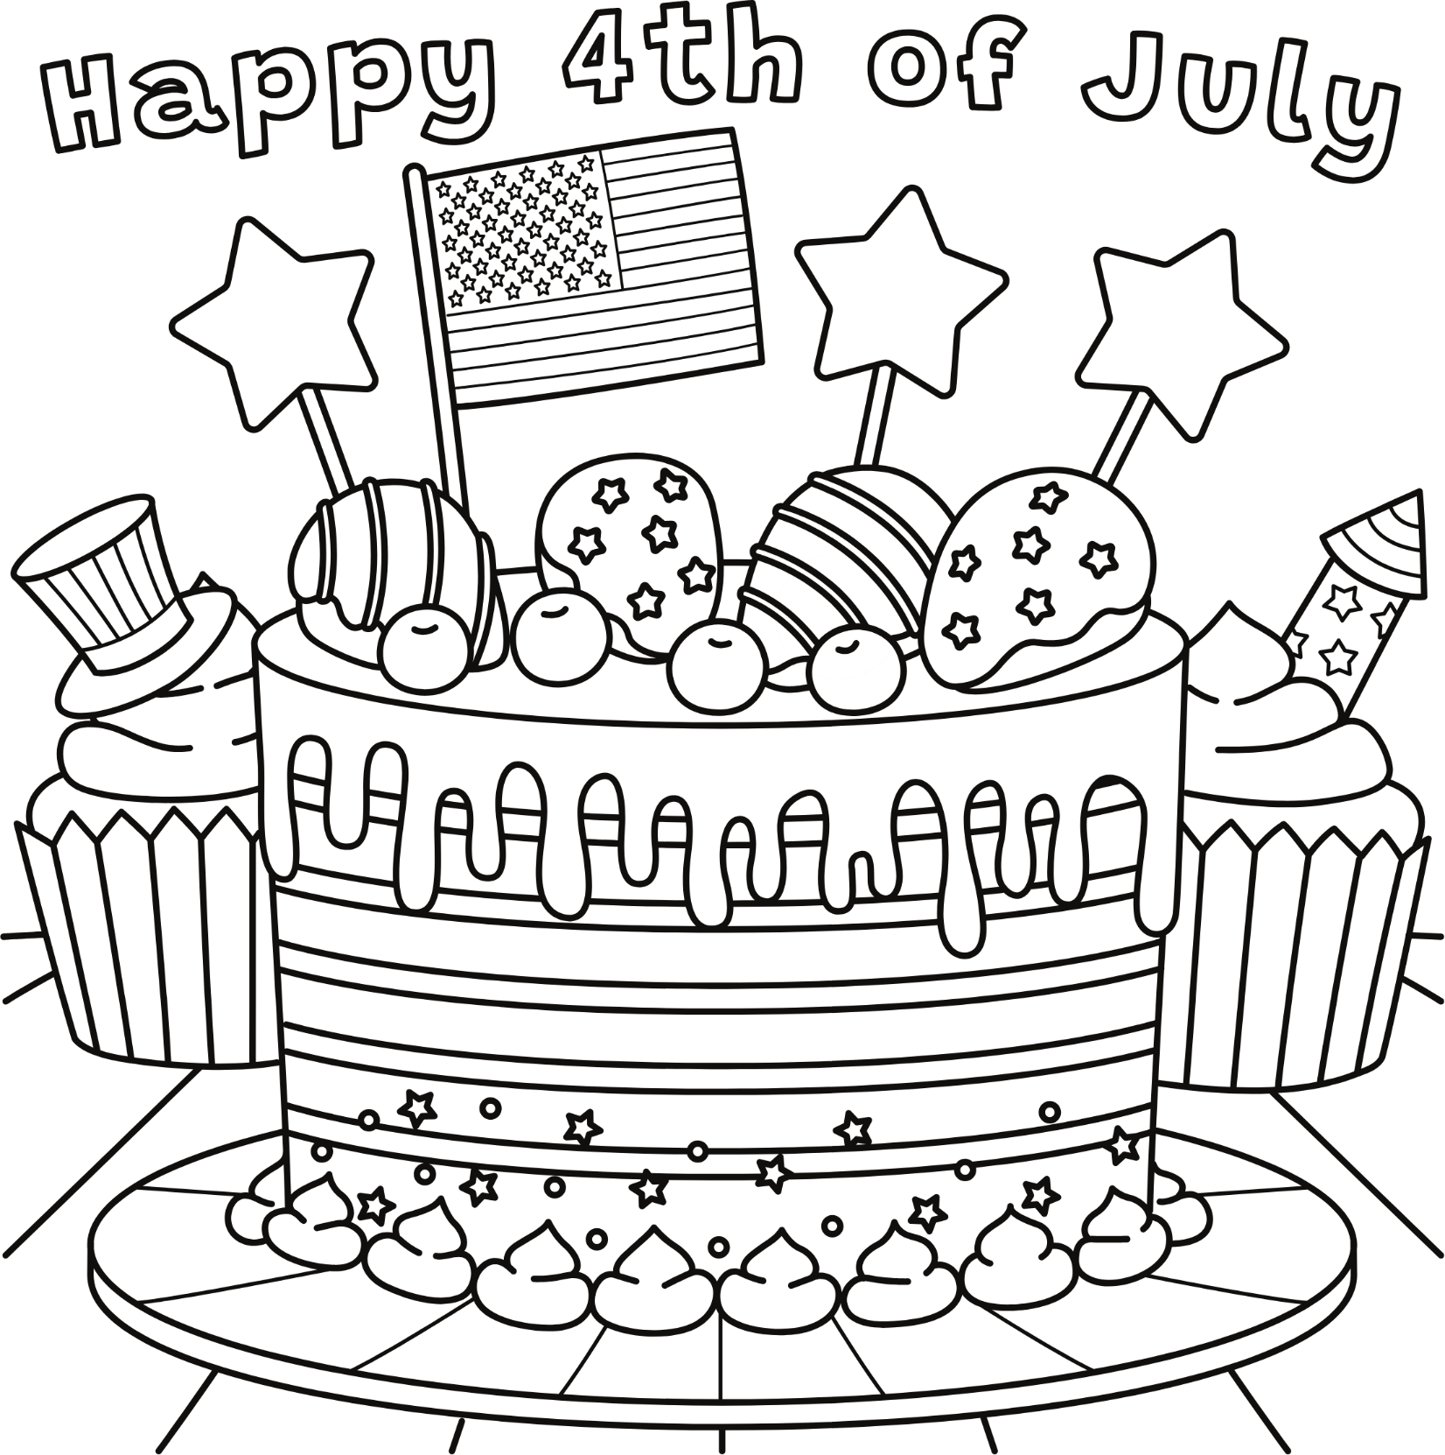

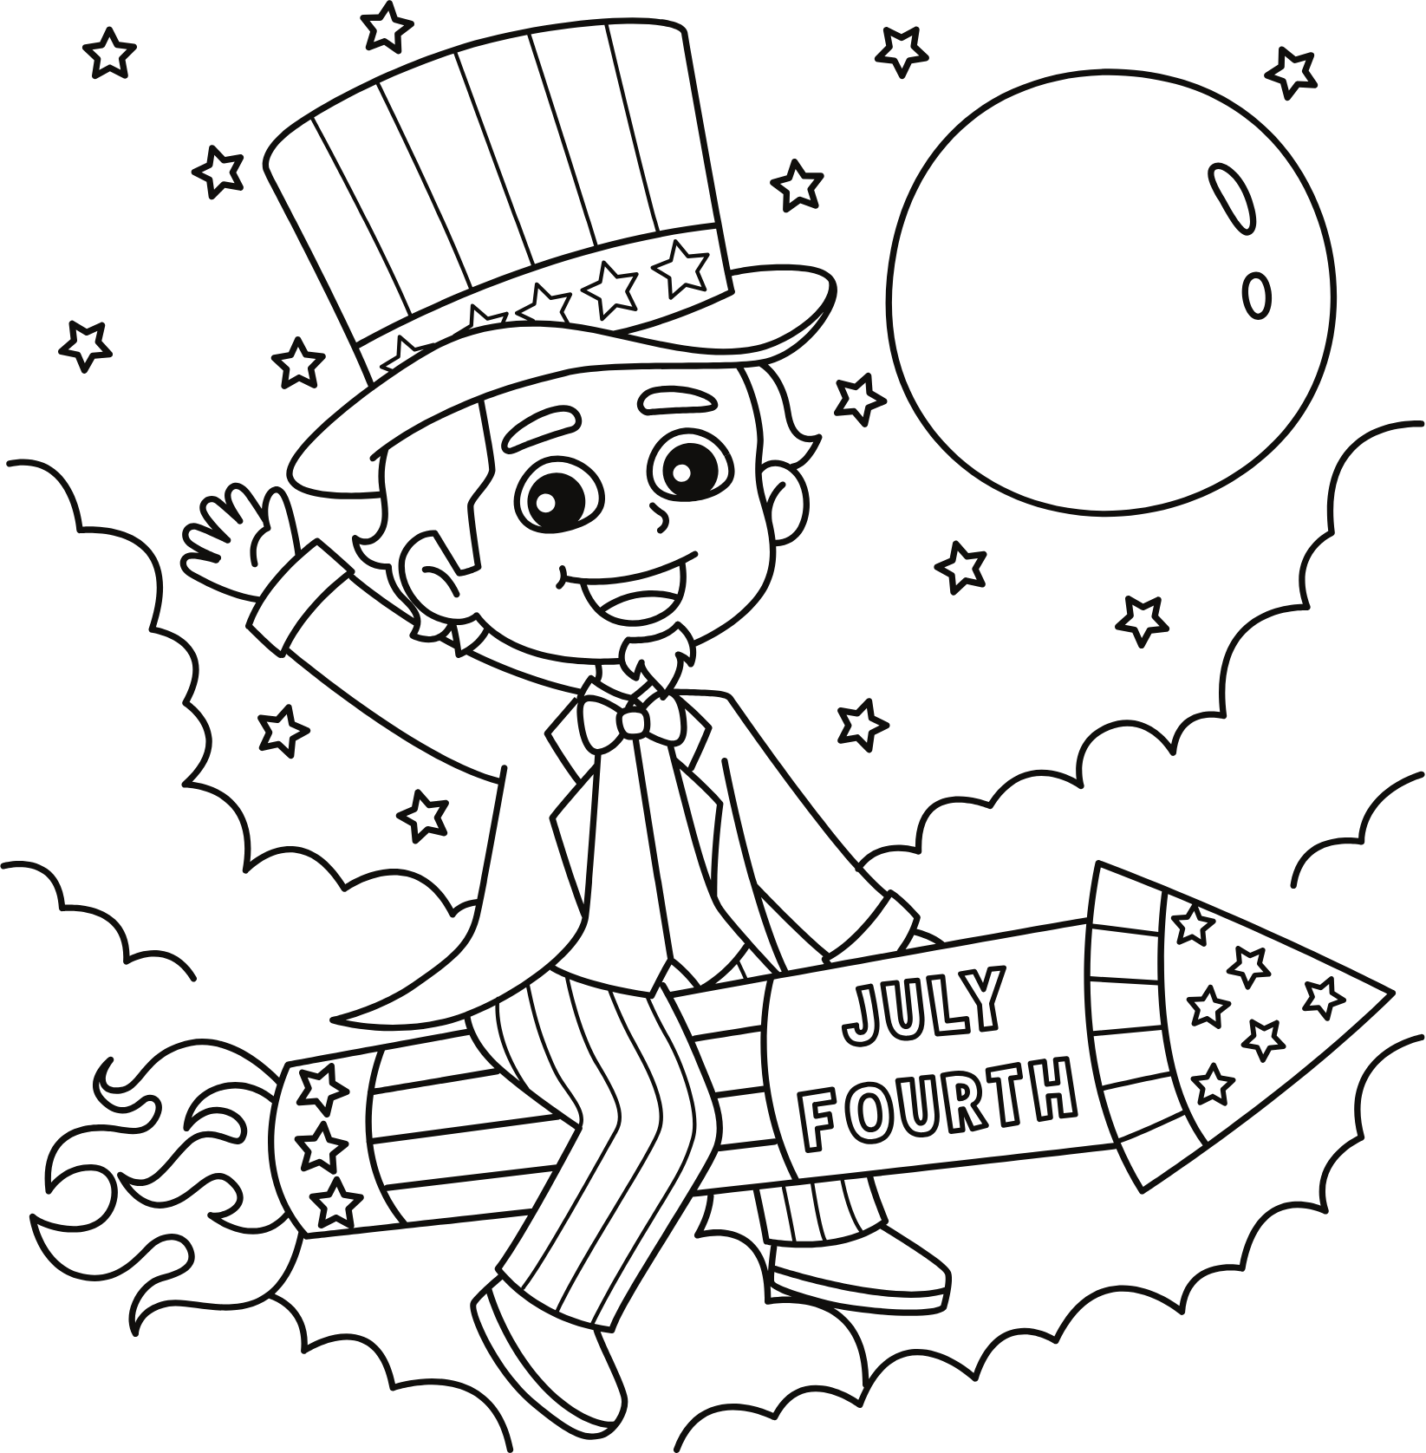





Without the answers



Backyard Trivia Challenge: Test Your Stars & Stripes Smarts!

Set up a trivia station near your picnic table or hang cards from your playset. Break into teams and keep score. The winning team gets a prize!

Sample Questions:
- How many original U.S. colonies? –
- Who wanted the turkey as the national bird? –
- Who wrote “The Star-Spangled Banner”? –
- Most American dessert? –
- Who signed the Declaration first? –
- Hot dogs eaten on the 4th of July? –
- What shape were the stars on the original flag? –
- Today the American flag has how many stars? -
- Who sewed the first American flag? -
- Who was the principal author of the Declaration of Independence? -

Fun Fourth of July Facts to Share

While waiting for fireworks or enjoying a snack, share these cool facts:
- President Calvin Coolidge was born on the ________________.
- In 1776, the U.S. population was just 2.5 million—now it’s over ___ million!
- Adams, Jefferson, and Monroe all died on ________.
- Joey Chestnut holds the hot dog-eating record at __!
- Hawaii became the ____ star on the flag in 1960.
- The national anthem was adopted in ____.
- John Hancock’s signature is the _______.
- Benjamin Franklin was the oldest Declaration signer at __.
- ___ American flags still stand on the moon.
- Americans spend over $_ _______ on fireworks each year.

Backyard Trivia Challenge: Test Your Stars & Stripes Smarts!

Set up a trivia station near your picnic table or hang cards from your playset. Break into teams and keep score. The winning team gets a prize!

Sample Questions:
- How many original U.S. colonies? – 13
- Who wanted the turkey as the national bird? – Benjamin Franklin
- Who wrote “The Star-Spangled Banner”? – Francis Scott Key
- Most American dessert? – Apple pie
- Who signed the Declaration first? – John Hancock
- Hot dogs eaten on the 4th of July? – Over 150 million
- What shape were the stars on the original flag? – A circle
- Today the American flag has how many stars? - 50
- Who sewed the first American flag? - Betsy Ross
- Who was the principal author of the Declaration of Independence? - Thomas Jefferson

Fun Fourth of July Facts to Share

While waiting for fireworks or enjoying a snack, share these cool facts:
- President Calvin Coolidge was born on the 4th of July.
- In 1776, the U.S. population was just 2.5 million—now it’s over 328 million!
- Adams, Jefferson, and Monroe all died on July 4th.
- Joey Chestnut holds the hot dog-eating record at 74!
- Hawaii became the 50th star on the flag in 1960.
- The national anthem was adopted in 1931.
- John Hancock’s signature is the largest.
- Benjamin Franklin was the oldest Declaration signer at 70.
- Six American flags still stand on the moon.
- Americans spend over $1 billion on fireworks each year.

