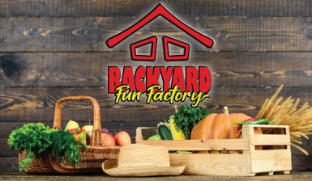

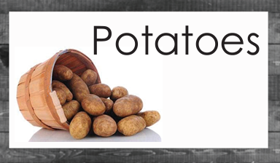

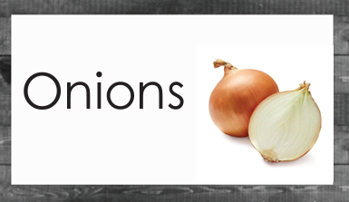

Blank to add your own fruit/vegetable name





